Finger millet

Table of Contents

## Load the working packages

library(AgroR)  
library(tidyverse)  
library(agricolae)  
library(lme4)  
library(emmeans)  
library(reshape)  
library(reshape2)  
library(car)

## Load the data

setwd("~/Code/R/SCASI")  
library(tidyverse)  
library(skimr)  
  
df <- readxl::read_excel("./input/SCASI_Field_Trials_Data_2022ALL_20230409_Adama_v2.xlsx",sheet = "MergePart2Part1")  
# First rows  
#knitr::kable(head(df))  
  
# Convert to factor  
df$Rep <- as.factor(df$Rep)  
df$Treatment <- as.factor(df$Treatment)  
df$Woreda <- as.factor(df$Woreda)

## Overview of the data

Number of observations and variables:

## [1] 709 153

## Extract data per crops

# crop_data  
crop_data <- df %>% filter(Plot_crop==params$crop)

## Descriptive statistics

### Yield accorss treatments

yield_trt_summary<- crop_data %>% group_by(Treatment) %>% summarize(across(.cols = c(GY_kg_ha,SY_kg_ha),list(min=min,max=max,mean=mean,sd=sd),na.rm=T,.names = "{.fn}_{.col}"))  
knitr::kable(yield_trt_summary)

|  |  |  |  |  |  |  |  |  |
| --- | --- | --- | --- | --- | --- | --- | --- | --- |
| Treatment | min_GY_kg_ha | max_GY_kg_ha | mean_GY_kg_ha | sd_GY_kg_ha | min_SY_kg_ha | max_SY_kg_ha | mean_SY_kg_ha | sd_SY_kg_ha |
| 1 | 72 | 1555.556 | 524.3761 | 485.0022 | 88 | 2377.778 | 979.9658 | 778.9529 |
| 2 | 120 | 1880.000 | 776.1368 | 462.2341 | 488 | 2616.000 | 1307.6923 | 704.7725 |
| 3 | 544 | 2266.667 | 1380.5470 | 629.5344 | 912 | 4248.000 | 2366.7863 | 1129.4608 |
| 4 | 432 | 2888.889 | 1340.2735 | 736.1624 | 720 | 5977.778 | 2667.4188 | 1506.1656 |
| 5 | 288 | 1622.222 | 1057.7778 | 460.2217 | 432 | 4904.000 | 2457.6068 | 1390.0891 |
| 6 | 208 | 1400.000 | 819.2479 | 366.2013 | 220 | 2777.778 | 1551.6239 | 798.3198 |
| 7 | 208 | 1488.889 | 808.7863 | 366.9794 | 344 | 2400.000 | 1506.5641 | 639.2143 |
| 8 | 96 | 2240.000 | 1182.1538 | 670.0535 | 152 | 3600.000 | 1969.1624 | 1080.1375 |

#yield_trt_summary  
#with(crop_data, desc(Treatment, GrainYield, ylab = "Grain Yield ", xlab = "Treatment", ylim = NA))  
  
#boxplot  
crop_data %>% select(GY_kg_ha, SY_kg_ha, Treatment) %>% gather(key = "Yields",value= "Value", -Treatment) %>%   
ggplot(aes(x=Treatment,y=Value, fill=Yields)) +  
 geom_boxplot() +  
 scale_fill_manual(values = c("GY_kg_ha" = "#dfc27d", "SY_kg_ha" = "#80cdc1"), labels=c("Grain", "Stover")) +  
 labs(y="Yield (Kg/ha)")+  
 theme_bw()+  
 theme(legend.title = element_text(size = 18),  
 legend.text = element_text(size = 16),  
 axis.title = element_text(size = 24),  
 axis.text = element_text(size = 20))

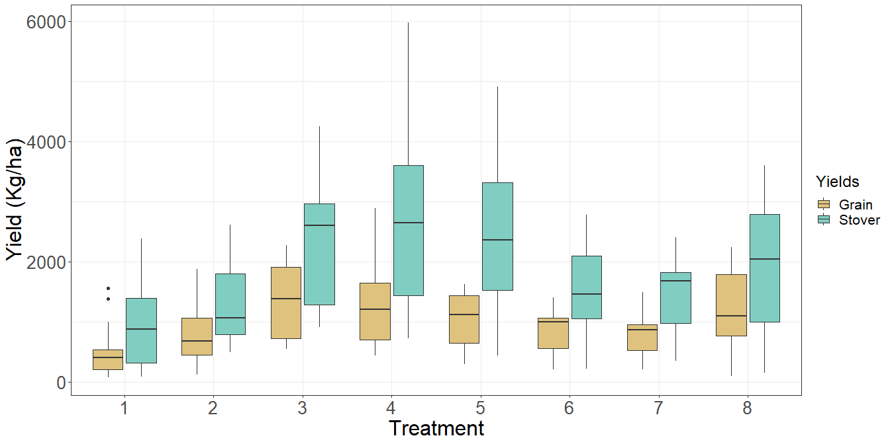

### Yield accorss locations

yield_location<- crop_data %>% group_by(Woreda) %>% summarize(across(.cols = c(GY_kg_ha,SY_kg_ha),list(min=min,max=max,mean=mean,sd=sd),na.rm=T,.names = "{.fn}_{.col}"))  
knitr::kable(yield_location)

|  |  |  |  |  |  |  |  |  |
| --- | --- | --- | --- | --- | --- | --- | --- | --- |
| Woreda | min_GY_kg_ha | max_GY_kg_ha | mean_GY_kg_ha | sd_GY_kg_ha | min_SY_kg_ha | max_SY_kg_ha | mean_SY_kg_ha | sd_SY_kg_ha |
| Sibu Sire | 72 | 2888.889 | 986.1624 | 592.3074 | 88 | 5977.778 | 1850.853 | 1161.72 |

#yield_trt_summary  
#with(crop_data, desc(Treatment, GrainYield, ylab = "Grain Yield ", xlab = "Treatment", ylim = NA))  
  
#boxplot  
crop_data %>% select(GY_kg_ha, SY_kg_ha, Woreda) %>% gather(key = "Yields",value= "Value", -Woreda) %>%   
ggplot(aes(x=Woreda,y=Value, fill=Yields)) +  
 geom_boxplot() +  
 scale_fill_manual(values = c("GY_kg_ha" = "#d01c8b", "SY_kg_ha" = "#4dac26"), labels=c("Grain", "Stover")) +  
 labs(y="Yield (Kg/ha)")+  
 theme_bw()+  
 theme(legend.title = element_text(size = 18),  
 legend.text = element_text(size = 16),  
 axis.title = element_text(size = 24),  
 axis.text = element_text(size = 20))

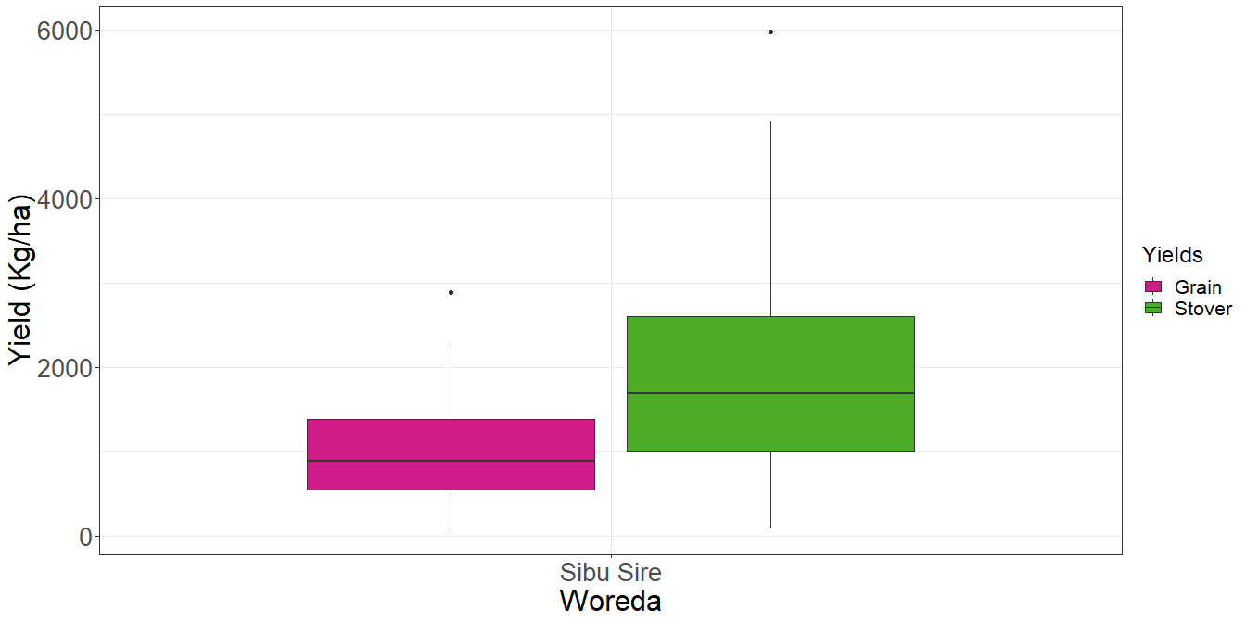

### Yield accorss locations and treatments

* Summary table

yield_location_trt<- crop_data %>% select(GY_kg_ha, SY_kg_ha, Woreda,Treatment) %>% group_by(Woreda,Treatment) %>% summarize(across(.cols = c(GY_kg_ha, SY_kg_ha),list(min=min,max=max,mean=mean,sd=sd),na.rm=T,.names = "{.fn}_{.col}"))

## `summarise()` has grouped output by 'Woreda'. You can override using the `.groups` argument.

knitr::kable(yield_location_trt)

|  |  |  |  |  |  |  |  |  |  |
| --- | --- | --- | --- | --- | --- | --- | --- | --- | --- |
| Woreda | Treatment | min_GY_kg_ha | max_GY_kg_ha | mean_GY_kg_ha | sd_GY_kg_ha | min_SY_kg_ha | max_SY_kg_ha | mean_SY_kg_ha | sd_SY_kg_ha |
| Sibu Sire | 1 | 72 | 1555.556 | 524.3761 | 485.0022 | 88 | 2377.778 | 979.9658 | 778.9529 |
| Sibu Sire | 2 | 120 | 1880.000 | 776.1368 | 462.2341 | 488 | 2616.000 | 1307.6923 | 704.7725 |
| Sibu Sire | 3 | 544 | 2266.667 | 1380.5470 | 629.5344 | 912 | 4248.000 | 2366.7863 | 1129.4608 |
| Sibu Sire | 4 | 432 | 2888.889 | 1340.2735 | 736.1624 | 720 | 5977.778 | 2667.4188 | 1506.1656 |
| Sibu Sire | 5 | 288 | 1622.222 | 1057.7778 | 460.2217 | 432 | 4904.000 | 2457.6068 | 1390.0891 |
| Sibu Sire | 6 | 208 | 1400.000 | 819.2479 | 366.2013 | 220 | 2777.778 | 1551.6239 | 798.3198 |
| Sibu Sire | 7 | 208 | 1488.889 | 808.7863 | 366.9794 | 344 | 2400.000 | 1506.5641 | 639.2143 |
| Sibu Sire | 8 | 96 | 2240.000 | 1182.1538 | 670.0535 | 152 | 3600.000 | 1969.1624 | 1080.1375 |

#yield_trt_summary  
#with(crop_data, desc(Treatment, GrainYield, ylab = "Grain Yield ", xlab = "Treatment", ylim = NA))

* Grain

#boxplot  
crop_data %>% select(GY_kg_ha, Woreda,Treatment) %>%   
ggplot(aes(x=Treatment,y=GY_kg_ha, fill=Woreda)) +  
 geom_boxplot() +  
 scale_fill_brewer(palette = "Set1") +  
 labs(y="Grain Yield (kg/ha)")+  
 theme_bw()+  
 theme(legend.title = element_text(size = 18),  
 legend.text = element_text(size = 16),  
 axis.title = element_text(size = 24),  
 axis.text = element_text(size = 20))

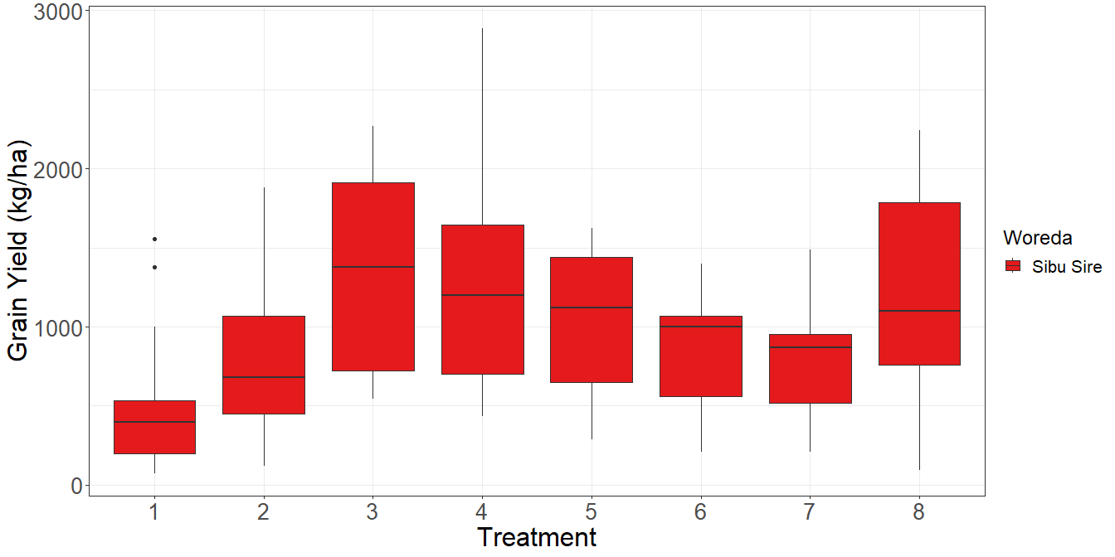

* Stover

#boxplot  
crop_data %>% select(SY_kg_ha, Woreda,Treatment) %>%   
ggplot(aes(x=Treatment,y=SY_kg_ha, fill=Woreda)) +  
 geom_boxplot() +  
 scale_fill_brewer(palette = "Set2") +  
 labs(y="Grain Yield (kg/ha)")+  
 theme_bw()+  
 theme(legend.title = element_text(size = 18),  
 legend.text = element_text(size = 16),  
 axis.title = element_text(size = 24),  
 axis.text = element_text(size = 20))

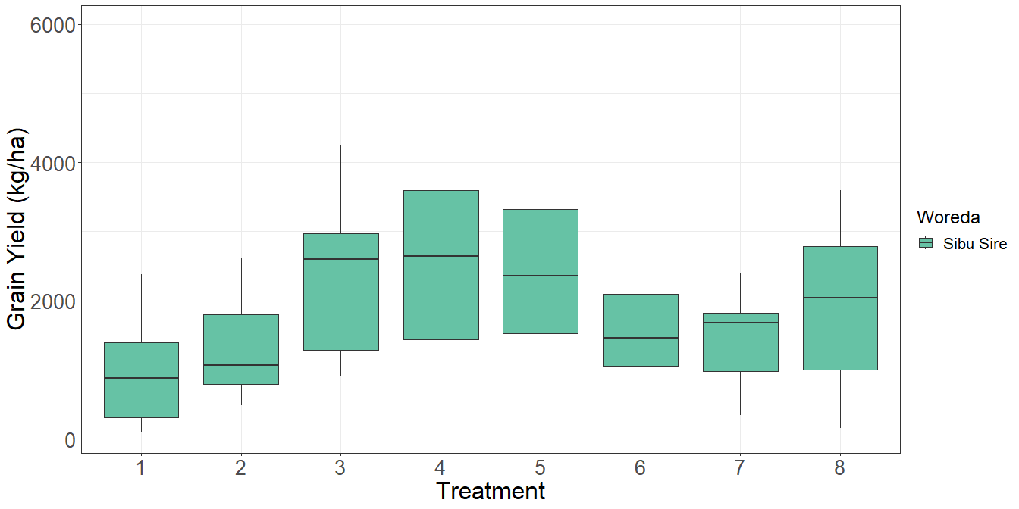

## Factorial analysis

# Analysis of variance  
  
#  
if (length(unique(crop_data$Woreda))<=1) {  
 model <- lm(GY_kg_ha~ Treatment, data=crop_data)  
 anova(model)  
} else {  
 model <- lm(GY_kg_ha~ Treatment + Woreda + (Treatment:Woreda) + (Woreda:Rep),data=crop_data)  
 anova(model)  
}

## Analysis of Variance Table  
##   
## Response: GY_kg_ha  
## Df Sum Sq Mean Sq F value Pr(>F)   
## Treatment 7 8335021 1190717 4.1118 0.0005446 ***  
## Residuals 96 27800270 289586   
## ---  
## Signif. codes: 0 '***' 0.001 '**' 0.01 '*' 0.05 '.' 0.1 ' ' 1

## Posthoc test

# Compute the estimated marginal means  
emmeans_result <- emmeans(model, ~ Treatment)  
  
# Perform pairwise comparisons using Tukey's adjustment  
pairwise_result <- pairs(emmeans_result, adjust = "tukey")  
  
# Display the pairwise comparisons  
knitr::kable(pairwise_result)

|  |  |  |  |  |  |
| --- | --- | --- | --- | --- | --- |
| contrast | estimate | SE | df | t.ratio | p.value |
| Treatment1 - Treatment2 | -251.76068 | 211.0728 | 96 | -1.1927672 | 0.9321522 |
| Treatment1 - Treatment3 | -856.17094 | 211.0728 | 96 | -4.0562833 | 0.0024888 |
| Treatment1 - Treatment4 | -815.89744 | 211.0728 | 96 | -3.8654794 | 0.0048005 |
| Treatment1 - Treatment5 | -533.40171 | 211.0728 | 96 | -2.5270986 | 0.1968596 |
| Treatment1 - Treatment6 | -294.87179 | 211.0728 | 96 | -1.3970149 | 0.8565028 |
| Treatment1 - Treatment7 | -284.41026 | 211.0728 | 96 | -1.3474512 | 0.8780275 |
| Treatment1 - Treatment8 | -657.77778 | 211.0728 | 96 | -3.1163555 | 0.0476757 |
| Treatment2 - Treatment3 | -604.41026 | 211.0728 | 96 | -2.8635160 | 0.0918545 |
| Treatment2 - Treatment4 | -564.13675 | 211.0728 | 96 | -2.6727121 | 0.1438626 |
| Treatment2 - Treatment5 | -281.64103 | 211.0728 | 96 | -1.3343314 | 0.8833887 |
| Treatment2 - Treatment6 | -43.11111 | 211.0728 | 96 | -0.2042476 | 0.9999992 |
| Treatment2 - Treatment7 | -32.64957 | 211.0728 | 96 | -0.1546840 | 0.9999999 |
| Treatment2 - Treatment8 | -406.01709 | 211.0728 | 96 | -1.9235882 | 0.5384442 |
| Treatment3 - Treatment4 | 40.27350 | 211.0728 | 96 | 0.1908039 | 0.9999995 |
| Treatment3 - Treatment5 | 322.76923 | 211.0728 | 96 | 1.5291846 | 0.7898117 |
| Treatment3 - Treatment6 | 561.29915 | 211.0728 | 96 | 2.6592684 | 0.1482475 |
| Treatment3 - Treatment7 | 571.76068 | 211.0728 | 96 | 2.7088321 | 0.1325733 |
| Treatment3 - Treatment8 | 198.39316 | 211.0728 | 96 | 0.9399278 | 0.9812479 |
| Treatment4 - Treatment5 | 282.49573 | 211.0728 | 96 | 1.3383807 | 0.8817492 |
| Treatment4 - Treatment6 | 521.02564 | 211.0728 | 96 | 2.4684645 | 0.2217206 |
| Treatment4 - Treatment7 | 531.48718 | 211.0728 | 96 | 2.5180282 | 0.2005713 |
| Treatment4 - Treatment8 | 158.11966 | 211.0728 | 96 | 0.7491239 | 0.9951461 |
| Treatment5 - Treatment6 | 238.52991 | 211.0728 | 96 | 1.1300838 | 0.9485468 |
| Treatment5 - Treatment7 | 248.99145 | 211.0728 | 96 | 1.1796474 | 0.9358393 |
| Treatment5 - Treatment8 | -124.37607 | 211.0728 | 96 | -0.5892568 | 0.9989377 |
| Treatment6 - Treatment7 | 10.46154 | 211.0728 | 96 | 0.0495637 | 1.0000000 |
| Treatment6 - Treatment8 | -362.90598 | 211.0728 | 96 | -1.7193406 | 0.6747625 |
| Treatment7 - Treatment8 | -373.36752 | 211.0728 | 96 | -1.7689043 | 0.6422963 |

#plot(pairwise_result, pch = "*", cex = 1.5)  
as_tibble(pairwise_result) %>%   
ggplot(aes(x=estimate,y=contrast)) +  
 geom_point(shape=23, size = 3, fill = "red") +  
 geom_errorbar(aes(xmin = estimate - SE, xmax = estimate + SE),  
 width = 0.2) +  
 labs(x = "Estimate", y = "Contrast")+  
 theme_bw()+  
 theme(axis.title = element_text(size = 16),  
 axis.text = element_text(size = 11))

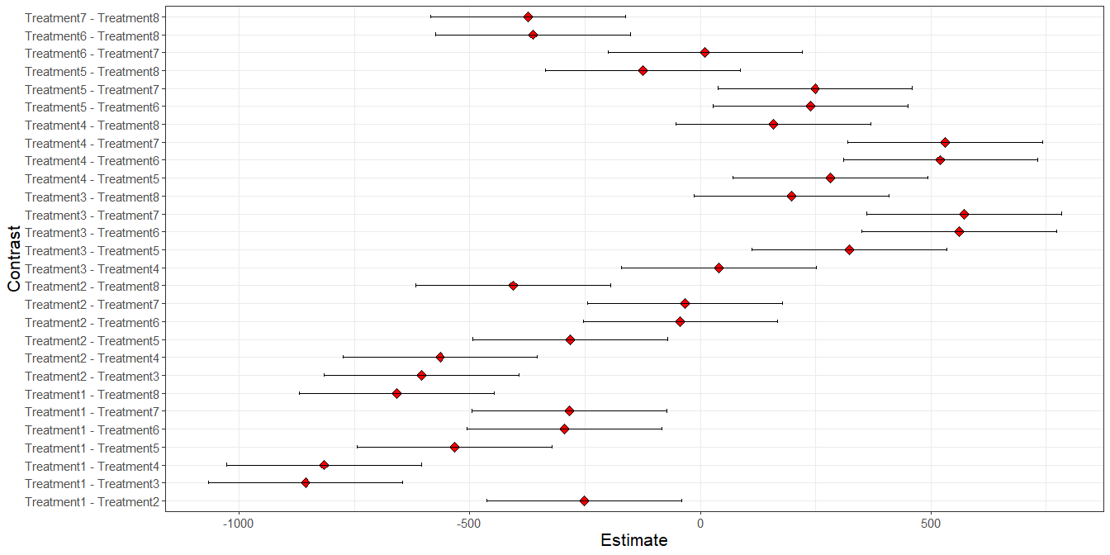

## Best treatment per location

### For every woreda, what are the 3 best treatment?

* Grain

best_comb<-yield_location_trt %>% select(Woreda, Treatment, mean_GY_kg_ha) %>%   
 group_by(Woreda) %>%  
 slice_max(mean_GY_kg_ha, n=3)  
knitr::kable(best_comb)

|  |  |  |
| --- | --- | --- |
| Woreda | Treatment | mean_GY_kg_ha |
| Sibu Sire | 3 | 1380.547 |
| Sibu Sire | 4 | 1340.274 |
| Sibu Sire | 8 | 1182.154 |

* Stover

best_comb<-yield_location_trt %>% select(Woreda, Treatment, mean_SY_kg_ha) %>%   
 group_by(Woreda) %>%  
 slice_max(mean_SY_kg_ha, n=3)  
knitr::kable(best_comb)

|  |  |  |
| --- | --- | --- |
| Woreda | Treatment | mean_SY_kg_ha |
| Sibu Sire | 4 | 2667.419 |
| Sibu Sire | 5 | 2457.607 |
| Sibu Sire | 3 | 2366.786 |